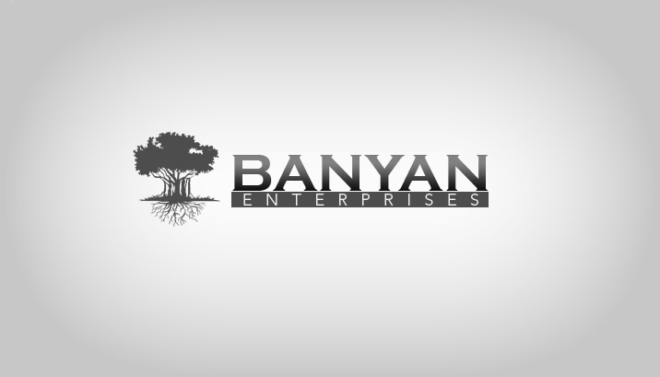
Business Synopsis
What do we do?
Banyan Enterprises goal is to become the largest source for hand-crafted or unique wares, with an emphasis towards the fast-growing, world-wide festival culture. Our mission is to help all these talented crafters live according to their passions by spreading the word, connecting them to their client base, and lending our organizational strengths to their talent and creativity. We have built an online emporium and are touring festivals all over the west coast as vendors and representatives to spread both word and style to our favorite people.
What Makes Us Special?
As long-time festival goers, we’ve met countless artisans who design and craft the most amazing apparel and accessories in the United States and even around the world. Usually, these types of products can ONLY be found at a festival being sold by the talented artists themselves. We recognized that we can help these people broaden their market, while simultaneously becoming a massive resource for inspired & unique wares found nowhere else online.
Our expertise in online business - from marketing and SEO to sales funnels and channels - will enable us to bridge the gap between these talented artists (who usually know very little about business online, and sometimes don’t care to) and the majority of their festival-going or adventurous client base. We are a fully functioning fulfillment warehouse and sales engine designed to relieve the pressures of online business from the artist, allowing them to focus on producing and designing their wares.
Revenue Model
Our revenue sources will be comprised of the following sources
- Online sales - driven by SEO expertise, click through advertising, newsletter subscribers, multiple sales channels (Facebook, shopping comparison sites, Ebay, Etsy, Google Products etc.) and word of mouth marketing. This most notably includes our own marketplace online, the Roachclip.com Emporium, which is already top ranked for several search terms and growing.
- Festival Vending Booths – we have set an aggressive schedule touring many west coast festivals to not only sell our products where they’re needed the most, but to market ourselves right where it counts.
- Affiliate Cross Promotion – we will generate revenue from continuing to build and market to our email list with not only our own products & specials, but affiliate partners’ products as well.
- Fulfillment Services – we help our partners succeed by adding our business strengths to their fulfillment process. In addition to online distribution channels, we offer storage, order fulfillment and customer returns for their products through our headquarters in San Diego. This not only removes the hassle of fulfillment, but gives us access to an ever growing supply of the world’s most unique wares.
Target Market
Music, Art and “Transformational” festivals are blowing up around the U.S (and the world). We have documented over 500 music festivals in North America alone, with more appearing every day. The rising popularity of this festival culture (particularly with electronic music) presents a unique opportunity to those who combine an understanding of the festival culture with business acumen.
This festival market has until recently been all but overlooked by major corporations and is ripe for the picking. We are preparing to ride the surge of festival culture popularity as it moves from the underground to the masses at large.
Current Partners
- Psylo Fashion (www.psylofashion.com)
- Electrofur (www.electrofur.com)
- Ethereal Elements (www.etherealelements.com)
- RockNSocks (www.rocknsocks.com)
- Foxy Monster (www.foxymonster.com)
- Wear With Attitude (www.wearwithattitude.com)
- The Coppersmith Designs (www.coppersmithdesign.com)
- Elope (www.elope.com)
- Sure Design Tees (www.suredesigntshirts.com)

Team & Experience
Matthew Leitz
Matt Leitz has had many years of experience with online business and has led several successful startup companies from concept to millions in revenue. He has now focused his work to what he feels most passionate about. His value as a leader, manager and visionary is what has made us what we are today.
Derek Zimmermann

Daniel Nareau

